**MCV4U Intersections Unit Assignment**

**Jin Hyung Park**

1. **The equation of a line can be determined using two points on the line.**
2. Find the vector, parametric and symmetric equations of the line through the points (–2, 3, 1) and (1, 4, –2).

* Vector Equation:
  + The point vector is [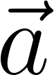](https://www.codecogs.com/eqnedit.php?latex=%5Cvec%7Ba%7D#0)
  + The direction vector is [](https://www.codecogs.com/eqnedit.php?latex=%5Cvec%7Bb%7D%3D(1-(-2)%2C4-3%2C-2-1)%3D%5Cvec%7Bb%7D%3D(3%2C1%2C-3)#0)
  + Substitute  and  into  is the following.
    - [](https://www.codecogs.com/eqnedit.php?latex=%5Bx%2Cy%2Cz%5D%3D%5B-2%2C3%2C1%5D%2Bt%5B3%2C1%2C-3%5D#0)
  + Therefore, the vector equation that passes through the given points is [](https://www.codecogs.com/eqnedit.php?latex=%5Bx%2Cy%2Cz%5D%3D%5B-2%2C3%2C1%5D%2Bt%5B3%2C1%2C-3%5D#0).
* Parametric Equation:
  + Rewrite the vector equation, [](https://www.codecogs.com/eqnedit.php?latex=%5Bx%2Cy%2Cz%5D%3D%5B-2%2C3%2C1%5D%2Bt%5B3%2C1%2C-3%5D#0), as the following.
  + [](https://www.codecogs.com/eqnedit.php?latex=%5B-2%2C3%2C1%5D%2Bt%5B3%2C1%2C-3%5D%3D(-2%2C3%2C1)%2B(3t%2C1t%2C-3t)#0)
  + [](https://www.codecogs.com/eqnedit.php?latex=x(t)%3D-2%2B3t%2C%20y(t)%3D3%2B1t%2C%20z(t)%3D1-3t#0)
* Symmetric Equation:
  + [](https://www.codecogs.com/eqnedit.php?latex=x(t)%3D-2%2B3t%2C%20y(t)%3D3%2B1t%2C%20z(t)%3D1-3t#0)
  + [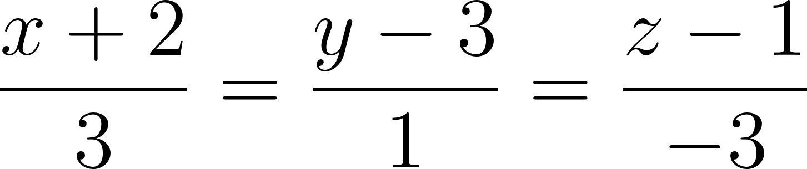](https://www.codecogs.com/eqnedit.php?latex=%5Cfrac%7Bx%2B2%7D%7B3%7D%3D%5Cfrac%7By-3%7D%7B1%7D%3D%5Cfrac%7Bz-1%7D%7B-3%7D#0)

1. Explain the features of the equations of a line that is parallel to the xz plane, but does not lie on the plane, and is not parallel to any of the axes. Include a LanGraph of your line.

* Features
  + Parallel to xy plane when the given Direction Vector is ${[b}_{x},b_{y},0]$
  + Not on the xy plane when the given Position Vector is $[a_{x},a_{y},a_{z}] where a_{z}≠0$
  + Not parallel to 3 axes when the given Direction vector is $[b_{x},b_{y},0] where b_{x}≠0, b_{y}≠0$
* Equations
  + [](https://www.codecogs.com/eqnedit.php?latex=%5Bx%2Cy%2Cz%5D%3D%5B-2%2C3%2C1%5D%2Bt%5B3%2C1%2C-3%5D#0)

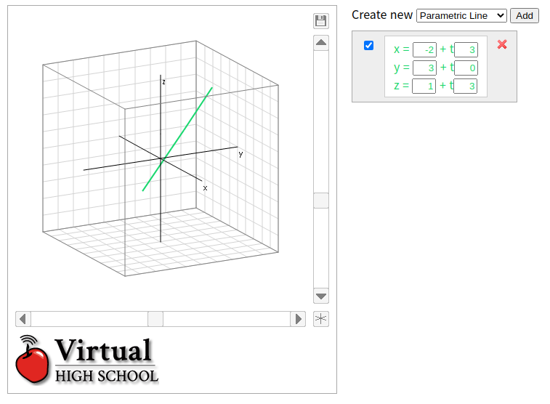

**2. Two given lines are either parallel, skew, or intersecting.**

1. Determine, if there is one, the point of intersection of the lines given by the equations.

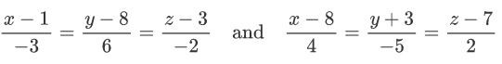

Given that, the point of intersection of the lines given by the equations, we can introduce variable t and s to get each point’s equation.

Introduce t variable: [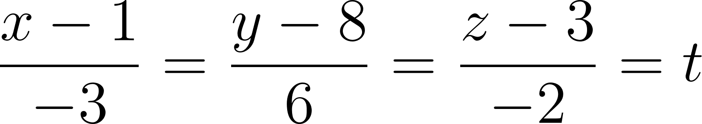](https://www.codecogs.com/eqnedit.php?latex=%5Cfrac%7Bx-1%7D%7B-3%7D%3D%5Cfrac%7By-8%7D%7B6%7D%3D%5Cfrac%7Bz-3%7D%7B-2%7D%3Dt#0)

[](https://www.codecogs.com/eqnedit.php?latex=x%3D-3t%2B1%2C%20y%3D6t%2B8%2C%20z%3D-2t%2B3#0)

Introduce s variable: [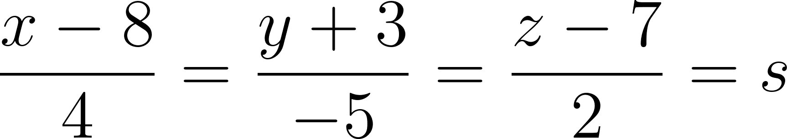](https://www.codecogs.com/eqnedit.php?latex=%5Cfrac%7Bx-8%7D%7B4%7D%3D%5Cfrac%7By%2B3%7D%7B-5%7D%3D%5Cfrac%7Bz-7%7D%7B2%7D%3Ds#0)

[](https://www.codecogs.com/eqnedit.php?latex=x%3D4s%2B8%2C%20y%3D-5s-3%2C%20z%3D2s%2B7#0)

Then, we can say that two lines will intersect.

[](https://www.codecogs.com/eqnedit.php?latex=-3t%2B1%3D4s%2B8%20%3D%3E%203t%2B4s%3D-7#0) -> (1)

[](https://www.codecogs.com/eqnedit.php?latex=6t%2B8%3D-5s-3%20%3D%3E%206t%2B5s%3D-11#0) -> (2)

Use (2), (3) to solve the variables.

$6t+8s=-14$-> $(1)×2$

$6t+5s=-11$-> (2)

$(6t+8s)-(6t+5s)=-14-(-11)$

$3s=-3, s=-1$

Substitute $s=-1$ into (1) equation:

$6t+8(-1)=-14$

$6t=-6, t=-1$

Thus, the point of intersection is $(x,y,z)=(-3t+1,6t+8,-2t+3)=(4,2,5)$

1. Give the equations of two lines that meet at the point (–1,5, 2) and which meet at right angles, but do not use that point in either of the equations. Explain your reasoning and include a LanGraph of your line.

The direction vectors of two perpendicular lines can be the following.

[](https://www.codecogs.com/eqnedit.php?latex=%5Cvec%7Bb1%7D%3D%5B1%2C2%2C3%5D%2C%20%5Cvec%7Bb2%7D%3D%5B-1%2C2%2C-1%5D%2C%20(%5Cvec%7Bb1%7D%5Ccdot%5Cvec%7Bb2%7D)%3D0#0)

The two lines must intersect the given points at (-1,5,2). Thus, we can write the following.

$L_{1}:[x,y,z]=[-1,5,2]+t [1,2,3]$

$L_{2}:[x,y,z]=[-1,5,2]+s [-1,2,-1]$

We can consider the following cases for each line to get a new position vector that intersects at (-1,5,2).

$I ) when t=1; [x,y,z]=[-1,5,2]+[1,2,3]=[0,7,5]$

$II ) when s=1; [x,y,z]=[-1,5,2]+[-1,2,-1]=[-2,7,1]$

Using new position vectors, $L_{1}=[x,y,z]=[0,7,5]+t [1,2,3]$

Using new position vectors,

3. The equation of a plane can be determined using three points on the plane.

* Find the vector, parametric and general equations of the plane through the points (2, –3, 1), (3, 1, 6), and (5, –1, 2).
* Give the equation of a plane that crosses the axes at points equidistant from the origin. Explain your reasoning and include a LanGraph of your plane.